**Final Report**

**Executive Summary**

**Summary of the Project, Objectives, and Outcomes:**

* **Explanation:** The Executive Summary provides a concise overview of the entire project. It highlights the key points, including the project's purpose, objectives, methodology, and major findings. It should be brief yet comprehensive, offering a snapshot of the project's scope and results for stakeholders who may not have the time to read the entire report.
  + **Project Summary:** A brief description of the customer segmentation project undertaken for a retail store using the Mall Customers dataset.
  + **Objectives:** The primary aim was to segment customers based on their purchasing behavior to enable targeted marketing strategies, improve customer satisfaction, and increase sales.
  + **Outcomes:** Summary of the key findings and insights gained from the clustering analysis, such as the identified customer segments, their characteristics, and recommendations for marketing strategies.

**Introduction**

**Project Background and Objectives:**

* **Explanation:** The Introduction sets the stage for the report by providing context and explaining the rationale behind the project. It introduces the problem the project aims to address and outlines the specific objectives that were set to solve this problem.
  + **Background:** Discuss the lack of understanding of customer profiles and the need for segmentation to improve marketing strategies.
  + **Objectives:** Clearly state the goals of the project, such as identifying distinct customer segments, understanding their behaviors and preferences, and leveraging this knowledge to enhance marketing efforts and customer engagement.

**Methodology**

**Steps Taken to Achieve the Objectives:**

* **Explanation:** The Methodology section details the systematic approach used to accomplish the project's objectives. It describes the processes, techniques, and tools employed at each stage of the project. This section provides transparency and allows others to replicate the study if needed.
  + **Data Collection:** Describe how the Mall Customers dataset was obtained and imported into the analysis environment.
  + **Data Cleaning:** Explain the steps taken to prepare the data, including handling missing values, encoding categorical variables, and normalizing numerical features.
  + **Exploratory Data Analysis (EDA):** Outline the EDA process, including the generation of descriptive statistics and visualizations to understand data distributions and relationships.
  + **Feature Selection:** Discuss the criteria and process for selecting features used in clustering, such as Age, Annual Income, and Spending Score.
  + **Clustering:** Provide details on the application of the K-Means clustering algorithm, including the determination of the optimal number of clusters and the evaluation of cluster quality using metrics like the silhouette score.
  + **Visualization:** Describe the creation of static and interactive visualizations using Matplotlib, Seaborn, and Power BI to present the clustering results and insights.
  + **Documentation:** Mention the preparation of comprehensive documentation to ensure the project is reproducible and understandable, including methodology, code snippets, and visualizations.

**Different charts which was visualized during project**

import matplotlib.pyplot as plt

import seaborn as sns

In [ ]:

*#histplot-Age,Annual income,Spending score*

*# Visualizing distributions*

plt.figure(figsize=(10, 6))

sns.histplot(data['Age'], bins=30, kde=True)

plt.title('Age Distribution')

plt.show()

plt.figure(figsize=(10, 6))

sns.histplot(data['AnnualIncome'], bins=30, kde=True)

plt.title('Annual Income Distribution')

plt.show()

plt.figure(figsize=(10, 6))

sns.histplot(data['SpendingScore'], bins=30, kde=True)

plt.title('Spending Score Distribution')

plt.show()

*# Visualizing relationships*

plt.figure(figsize=(10, 6))

sns.scatterplot(data=data, x='AnnualIncome', y='SpendingScore', hue='Gender')

plt.title('Income vs Spending Score')

plt.show()

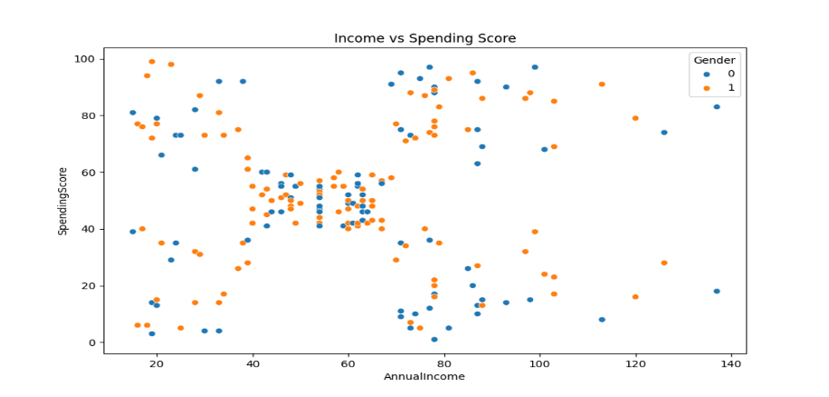

Plotting the Line Graph with WCSS Values to get the exact ideal number of clusters to be created using KMeans Clustering Algorithm and saving the PNG file of the graph.

In [17]:

plt.plot(range(2,11),wcss)

plt.title('Elbow Method')

plt.xlabel('No. of Clusters')

plt.ylabel('WCSS')

plt.savefig('Elbow Method Graph.png')

plt.show()

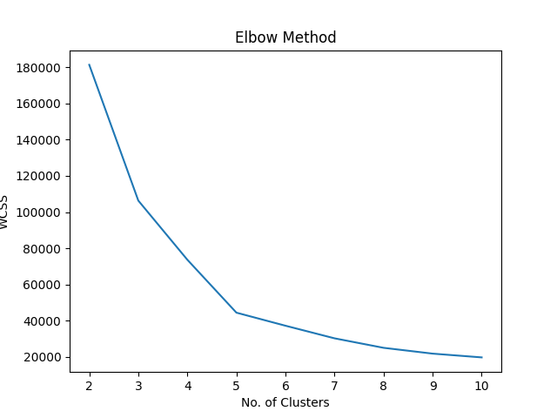

kmeans=KMeans(n_clusters=5)

kmeans.fit(x)

y_kmeans=kmeans.labels_

display(y_kmeans)

/usr/local/lib/python3.10/dist-packages/sklearn/cluster/_kmeans.py:870: FutureWarning: The default value of `n_init` will change from 10 to 'auto' in 1.4. Set the value of `n_init` explicitly to suppress the warning

warnings.warn(

array([4, 2, 4, 2, 4, 2, 4, 2, 4, 2, 4, 2, 4, 2, 4, 2, 4, 2, 4, 2, 4, 2,

4, 2, 4, 2, 4, 2, 4, 2, 4, 2, 4, 2, 4, 2, 4, 2, 4, 2, 4, 2, 4, 0,

4, 2, 0, 0, 0, 0, 0, 0, 0, 0, 0, 0, 0, 0, 0, 0, 0, 0, 0, 0, 0, 0,

0, 0, 0, 0, 0, 0, 0, 0, 0, 0, 0, 0, 0, 0, 0, 0, 0, 0, 0, 0, 0, 0,

0, 0, 0, 0, 0, 0, 0, 0, 0, 0, 0, 0, 0, 0, 0, 0, 0, 0, 0, 0, 0, 0,

0, 0, 0, 0, 0, 0, 0, 0, 0, 0, 0, 0, 0, 1, 3, 1, 0, 1, 3, 1, 3, 1,

0, 1, 3, 1, 3, 1, 3, 1, 3, 1, 0, 1, 3, 1, 3, 1, 3, 1, 3, 1, 3, 1,

3, 1, 3, 1, 3, 1, 3, 1, 3, 1, 3, 1, 3, 1, 3, 1, 3, 1, 3, 1, 3, 1,

3, 1, 3, 1, 3, 1, 3, 1, 3, 1, 3, 1, 3, 1, 3, 1, 3, 1, 3, 1, 3, 1,

3, 1], dtype=int32)

Plotting the Scatter Plot Graph with the independent variable and the Cluster which it belongs and saving the PNG file.

In [19]:

plt.scatter(x[y_kmeans==0,0],x[y_kmeans==0,1],c='r',s=100,label='Cluster 1')

plt.scatter(x[y_kmeans==1,0],x[y_kmeans==1,1],c='b',s=100,label='Cluster 2')

plt.scatter(x[y_kmeans==2,0],x[y_kmeans==2,1],c='g',s=100,label='Cluster 3')

plt.scatter(x[y_kmeans==3,0],x[y_kmeans==3,1],c='m',s=100,label='Cluster 4')

plt.scatter(x[y_kmeans==4,0],x[y_kmeans==4,1],c='c',s=100,label='Cluster 5')

plt.title('KMeans Clustering Spread')

plt.savefig('Kmeans Clustering Spread Graph.png')

plt.legend()

plt.show()

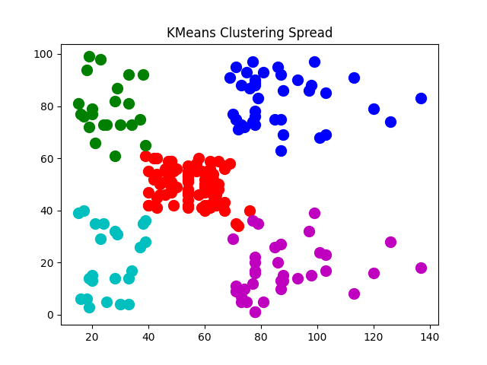

You can explore all through my GitHub link: <https://github.com/Sriramanenivikas/Mall-Customer-Segmentation-Project/tree/main>

_______Thank You_______